Choose the letter of the answer to each problem. In all cases, NOTA means “none of these answers.

1) Horton loves to do equations. He comes across the problem 2.6 + 0.4x = 1.4x + 5.6. What solution should Horton find for x?
A) 8.2 B)  C) 3 D) -3 E) NOTA

2) Write an equation of the line passing through the points (0, 4) and (1, 3).
A) y = -x + 4 B) y = x + 4 C) y = -x + 3 D) y = x + 3 E) NOTA

3) Simplify. 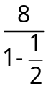
A) 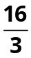 B) 8 C) 12 D) 16 E) NOTA

4) At Whoville Elementary School, there are 115 Whos in Jojo’s class. They can juggle, play an instrument, do both, or do neither. Thirty-seven Whos can juggle, 27 can both juggle and play an instrument, and 7 can neither juggle nor play an instrument. How many Whos can only play an instrument?
A) 78 B) 61 C) 51 D) 44 E) NOTA

5) Simplify. 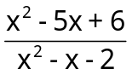
A) 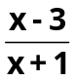 B) 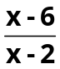 C) 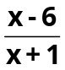 D) 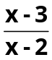 E) NOTA

6) What is the greatest common factor for 15x⁵²yz¹²⁰ and 6x²⁶z¹⁰ ?
A) 3x²⁶z¹⁰ B) 3x⁵²yz¹²⁰ C) 30x²⁶z¹⁰ D) 30x⁵²y¹²⁰ E) NOTA

7) What is the least common multiple for 15x⁵²yz¹²⁰ and 6x²⁶z¹⁰ ?
A) 3x²⁶z¹⁰ B) 3x⁵²yz¹²⁰ C) 30x²⁶z¹⁰ D) 30x⁵²yz¹²⁰ E) NOTA

8) Find the sum of the reciprocals of all of the factors, positive and negative, for 54.
A) 120 B)  C)  D) 0 E) NOTA

9) Horton is 24 years older than Ally, Jojo’s sister. Jojo is 5 times as old as his sister, Ally, and 5 times younger than Horton. How old is Horton?
A) 1 B) 5 C) 25 D) Not enough information E) NOTA

10) The formula for converting degrees in Celsius to Fahrenheit is 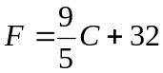 where F represents the degrees in Fahrenheit and C represents the degrees in Celsius. What is 50° Celsius in degrees Fahrenheit?
A) 10° B) 58° C) 59.8° D) 122° E) NOTA

11) The sum of two numbers is 42. The larger of the two numbers is nine less than twice the smaller number. Find the positive difference of the two numbers.
A) 8 B) 20 C) 108 D) 144 E) NOTA

12) A fraction exists with both the numerator and the denominator positive. If you subtract 1 from the denominator, the resulting fraction is equivalent to . Which of the following can be the original fraction?
A)  B)  C) 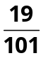 D)  E) NOTA

13) If 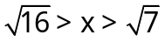, which of the following values could be x?
A) 2 B) 2.2 C) 3.2 D) 4.1 E) NOTA

14) If a ¤ b = ab + a – b, what is (3 ¤ 2) ¤ 7?
A) 21 B) 42 C) 44 D) 49 E) NOTA

15) Factor completely. x² + 3x² – 4
A) 4(x – 2)² B) 4(x + 1)(x – 1) C) 4(x + 2)² D) (x + 4)(x – 1) E) NOTA

16) Livda and Aisa are running on a circular track. They start at the same point, but run in opposite directions. Livda runs clockwise while Aisa runs counterclockwise. Livda runs at a rate of 4 meters per second while Aisa runs 3 meters per second. The whole track is 70 meters long. How many seconds will it take until they meet for the 7th time (the starting point does not count as the first time they meet)?
A) 35 B) 70 C) 140 D) 180 E) NOTA

17) Gene is given x dollars for his birthday. He spends  of his money to buy new strings for his yo-yo. Then, Gene spends of the remaining money buying Batman and Joker toys leaving him with $12. How much money was Gene originally given for his birthday?
A) $60 B) $30 C) $24 D) $12 E) NOTA

18) Vlad is a very common name in the jungle of Nool. There are 37 bunnies with cookies named Vlad and 74 vultures named Vlad. When Morton warns Horton that Vlad is coming, what is the probability that a bunny with cookies is coming?
A)  B)  C)  D)  E) NOTA

19) The mayor has 99 children. Some are in his house and the others are not in his house. If you take the children in the house and arrange them in rows of 5, you get x rows and 3 children left over. If you take the children in the house and arrange them in rows of 7, you get x – 1 rows and no children left over. What is the largest possible number of children not in the house?
A) 28 B) 35 C) 63 D) 71 E) NOTA

20) Solve. 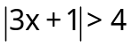
A) 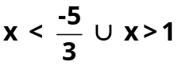 B) 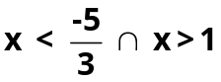 C) x > 1

D) 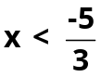 E) NOTA

21) Rewrite the following in Standard Form : 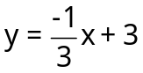.
A) x + 3y = -9 B) x + 3y = 9 C) x = 9 – 3y
D) 9 – 3y = x E) NOTA

22) Rationalize the denominator : 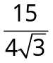
A) 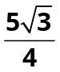 B) 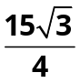 C)  D)  E) NOTA

23) Solve : 4x² + 3x – 4 = 0

A)  B) 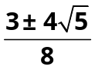 C) 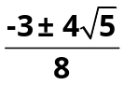 D) 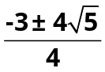 E) NOTA

24) What is the sum of the solutions for 3x² – 5x + 7 = 0 ?

A)  B)  C) D)  E) NOTA
25) Horton starts at the point (0,0) and runs five units from Vlad in the positive direction and then falls off a cliff and drops 5 units straight downward. What is the distance from Horton’s start point to his end point?

A) 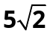 B) 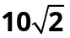 C) 20 D) 25 E) NOTA

26) What is the equation for a line passing through the point (1,1) and perpendicular to the line passing through (0,0) and (1,2)?

A) y = 2x - 1 B) y = x C) 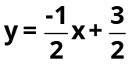 D) 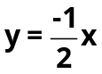 E) NOTA

27) The Mayor can mow a lawn in 3 hours, and Jojo can mow a lawn in 5 hours. How many lawns can they mow, working together in 30 hours?

A) 3 lawns B) 5 lawns C) 8 lawns D) 16 lawns E) NOTA

28) What is the midpoint of (2,3) and (0,1)?

A) (0,1) B) (1,2) C) (2,3) D) (2,2) E) NOTA

29) Where do the lines 2x - y = 0 and x - y = 3 intersect?
A) (3,6) B) (1,1) C) (6,3) D) (2,1) E) NOTA

30) Simplify 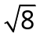.
A) 2 B) 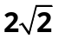 C) 4 D) 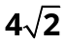 E) NOTA

